Management of Health and Safety at Work Regulations
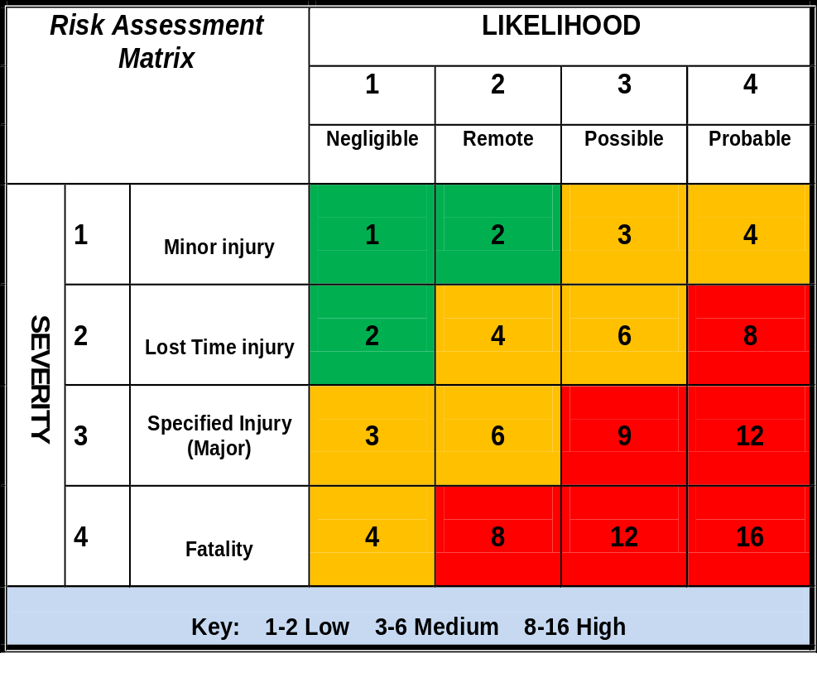ALARP RISK ASSESSMENT
Personnel undertaking the Risk Assessment must be led by an ALARP Trained Risk Assessor.

Reviews should be completed using RA Review Form
Sect 2.2 / 1.1.2 or a suitable alternative which should be retained with this form.

Task Description : APV AHV PLC Migration and HMI upgrade

Site : | Lifton
Department: | Engineering
Location : | APV AHV Process Area
Completed By : | Nathan Harris
Lead assessor Signature: | Dave Stephens
Date of Assessment : | 26/09/2025
Overall risk rating: | High / Medium / Low

OTHER RELEVANT SPECIFIC ASSESSMENTS
 | Required  Yes/No | Reference No’s.
COSHH | N
Manual Handling | Y | H&S Procedures Section 2.2-6.1
Machine safety (PUWER) | Y | Group Forms Ref. F 6.23.1: Combi PUWER 3
Noise at work | Y | Site Noise Survey
PPE | N
Other:

1. TASK ANALYSIS / RISK EVALUATION
Risk ratings: The residual risk should be assessed after taking into consideration controls which are in place. Use matrix on Page 1. L- Likelihood S- Severity R- Risk
Job Steps | Haz. Ref. No | Details of hazards and the risk to health and safety they pose | Controls / Precautions in place and implemented | Residual Risk Levels
 |  |  |  | L | S | R | H  M  L
Analysis of current PLC/HMI architecture | 1 | Wet floor – Slips/trips and falls | Wear appropriate company issued safety shoes EN ISO 20345 | 1 | 1 | 1 | L
Isolate panel for work | 2 | Electricity – Electric shock | Works to be carried out by competent person  Lock out and tag procedure to be followed | 1 | 1 | 1 | L
Remove old PLC and replace with new PLC | 3 | Hand Tools – hand/arm injury | Check tools are in good condition before starting work  Use correct tools for the task  Tools are company issue | 1 | 1 | 1 | L
Remove HMI from panel door, and remove the panel door to hot works area | 4 | Manual Handling – back injury, knocks, grazes | Use correct manual handling techniques | 1 | 1 | 1 | L
Modify existing panel cut-out to for new HMI | 5 | Hot works – Ejected debris from cutting, burns, cuts | Works carried out by a competent person  Correct PPE to be worn (i.e goggles, gloves etc) | 1 | 2 | 2 | L
Refit door and fit new HMI in panel door | 6 | Manual Handling – back injury, knocks, grazes  Hand Tools – hand/arm injury | Use correct manual handling techniques  Use correct tools for the task  Tools are company issue | 1 | 1 | 1 | L
2. RESIDUAL RISK - ACTIONS REQUIRED
Ensure that any further control measures identified or recommended are sufficient to reduce the risk As Low As is Reasonably Practicable (ALARP).
Use matrix on Page 1. L- Likelihood S- Severity R- Risk
Haz  RefNo. | ACTIONS RECOMMENDED | Person(s)  Responsible | Target Date | Date Completed | ACTIONS CARRIED OUT | Residual Risk Levels
 |  |  |  |  |  | L | S | R | H  M  L

